Birla Institute of Technology & Science, Pilani

Blockchain Assignment

**Program Title : M Tech Software Engineering / Software Systems**

**Course No*.*** : **SE ZG569**

**Course Title : Assignment**

* Blockchain Assignment
* **Project team** member name and BITS IDs

|  |  |  |
| --- | --- | --- |
| BITS ID | Name | Email |
| 2020mt93550 | Pamuru KesavaKumar | 2020mt93550@wilp.bits-pilani.ac.in |

* **Working title** – Electronic Voting System using Blockchain
* **Executive Summary** – This assignment is mainly to build Blockchain based solution for solving various problems faced in traditional voting process. This project is to design and build an electronic voting system, where we use of Solidity Smart Contracts to create a **decentralized** voting application.
* **Project Background, Objectives** –

This project is mainly to build Blockchain based voting system to solve various problems involved in traditional voting system.

Traditional paper-based voting, voting via digital voting machines, or an online voting system, several conditions need to be satisfied:

* Eligibility: Only legitimate voters should be able to take part in voting;
* Unreusability: Each voter can vote only once;
* Privacy: No one except the voter can obtain information about the voter’s choice;
* Fairness: No one can obtain intermediate voting results;
* Soundness: Invalid ballots should be detected and not taken into account during tallying;
* Completeness: All valid ballots should be tallied correctly
* **System Architecture:**

***Core Components of Blockchain Architecture***

These are the main architectural components of Blockchain as mentioned below.

• *Node*:

Users or computers in blockchain layout (every device has a different copy of a complete ledger from the blockchain);

• *Transaction*:

It is the blockchain system’s smallest building block (records and details),

which blockchain uses;

• *Block*:

A block is a collection of data structures used to process transactions over the network distributed to all nodes.

• *Chain*: A series of blocks in a particular order;

• *Miners*: Correspondent nodes to validate the transaction and add that block into

the blockchain system;

• *Consensus*: A collection of commands and organizations to carry out blockchain

processes.

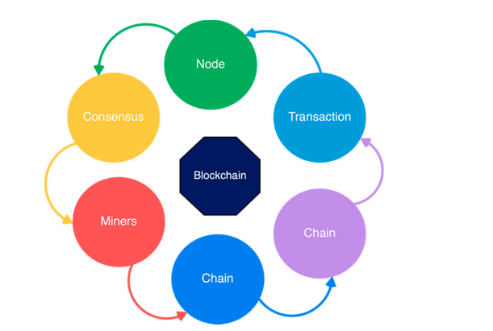

*Diagram – core components of blockchain*

***Critical Characteristics of Blockchain Architecture***

Blockchain architecture has many benefits for all sectors that incorporate blockchain. Here are a variety of embedded characteristics under below diagram.

• Cryptography: Blockchain transactions are authenticated and accurate because of computations and cryptographic evidence between the parties involved;

• Immutability: Any blockchain documents cannot be changed or deleted;

• Provenance: It refers to the fact that every transaction can be tracked in the blockchain ledger;

• Decentralization: The entire distributed database may be accessible by all members of the blockchain network. A consensus algorithm allows control of the system, as shown in the core process;

• Anonymity: A blockchain network participant has generated an address rather than a user identification. It maintains anonymity, especially in a blockchain public system.

• Transparency: It means being unable to manipulate the blockchain network. It does not happen as it takes immense computational resources to erase block chain network.

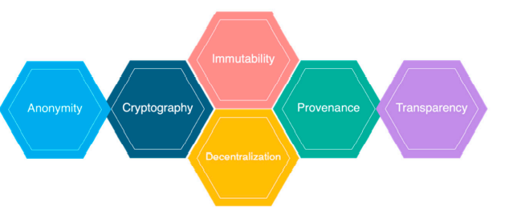

*Diagram – Characteristics of Blockchain Architecture.*

1. **Traditional vs Blockchain voting system**

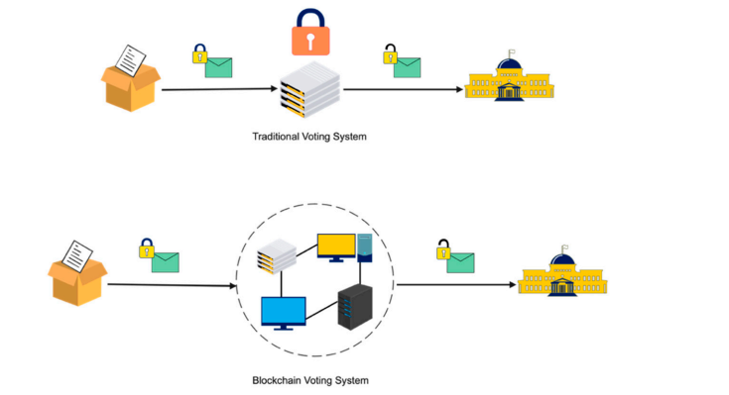

If Technology is used correctly, the blockchain is a digital, decentralized, encrypted, transparent ledger that can withstand manipulation and fraud. Because of the distributed structure of the blockchain, a Bitcoin electronic voting system reduces the risks involved with electronic voting and allows for a tamper-proof for the voting system. A blockchain-based electronic voting system requires a wholly distributed voting infrastructure. Electronic voting based on blockchain will only work where the online voting system is fully controlled by no single body, not even the government. To sum-up, elections can only be free and fair when there is a broad belief in the legitimacy of the power held by those in positions of authority. The literature review for this field of study and other related experiments may be seen as a good path for making voting more efficient in terms of administration and participation. However, the idea of using blockchain offered a new model for electronic voting.

1. **Blockchain voting systems architecture overview:**

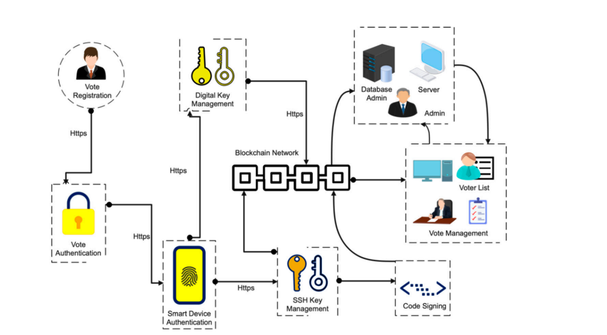

1. **Key Modules**

Electronic voting system consists of organizing authority, a voting machine and a vote.

In case of system, used Ethereum based blockchain to establish the network between the three mentioned entities.

This is a decentralized web application, main components are mentioned below.

* Smart Contracts
* Ballot smart contract

-The Ballot smart contract is where the votes are recorded.

* Election creation smart contract

- The election creation smart contract is what is used to deploy the ballots on the blockchain.

* Front-end for Election Commission, Voter’s interface.
* Voter Authentication Services [ Validate Voter Identity]

1. **Relevance** — This assignment mainly helps in understanding and developing the blockchain based application, which is part of the degree program.
2. **Resources required** – Node.js, Ethereum Solidity smart contracts,

Java Script, HTLM, CSS, Ganache.

1. **Advantages –** The Key advantages of using blockchain voting system are
   * + 1. Transparency,
       2. Immutable
       3. Secure
2. **Risks**/**Disadvantages**– The Key areas where blockchain applications can fail are
3. Adaptability, Scalability
4. Slower progress, Self-Maintenance
5. High Cost, Still not mature
6. **Source Code/Front end -** Refer the attached files/details for the same basic modules and code.
7. **Details -**

1. Voters Identity

* Voter to enter identity details
* Identity details submitted are gets verified online with data maintained at

election commission organizations.

* All the information will be added to Voter Block chain
* Smart contract will be executed that will issue Ballot

2. Casting the Vote

* Polling System consult the voter blockchain ensure to verify that voter already
* voted or not.
* User Vote is valid polling station accepts the vote, if its invalid polling station gets rejected.
* After voting vote becomes transaction and get stored in blockchain after
* encryption.
* Once the vote is casted it cannot be modified because of the immutable

characteristic of block chain.

* Vote will be allowed to print the casting of the vote as proof of casting the vote.
* Voter can even audit each ballot in the ballot box and confirm if the election

results are accurate.